Objectives:

* Connecting to an outside source DB >> using Access
* Creating a GUI App using Java Code
* Using the DML Statements such as: Select, Insert, Update and Delete

**There are 7 print screens, each worth 12.5%.**

**Project #1**

1. Open Microsoft Access and clicking on Search and type Access
2. Click on the Blank Desktop Database 1x (DO NOT double click on it) and rename the database name to **Students** as shown below:

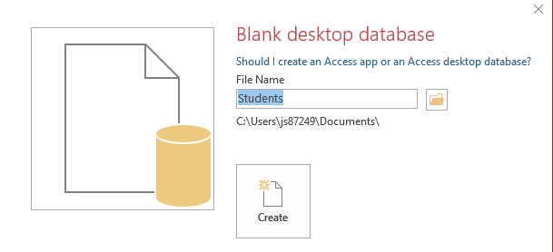

1. To redirect the location of the database, click on the folder icon and choose your desktop and then click on the Create button
2. To create a new query, click on the Create menu >> Query Design >> Right Click on the Gray Pane and click on SQL View then type in the following command





1. Create another table as shown below

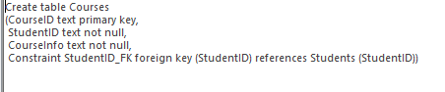

1. Enter the following row into the new table



1. Create the ERD Diagram

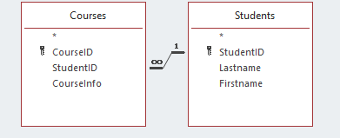

1. Create a new project for Java and type in the following code below:

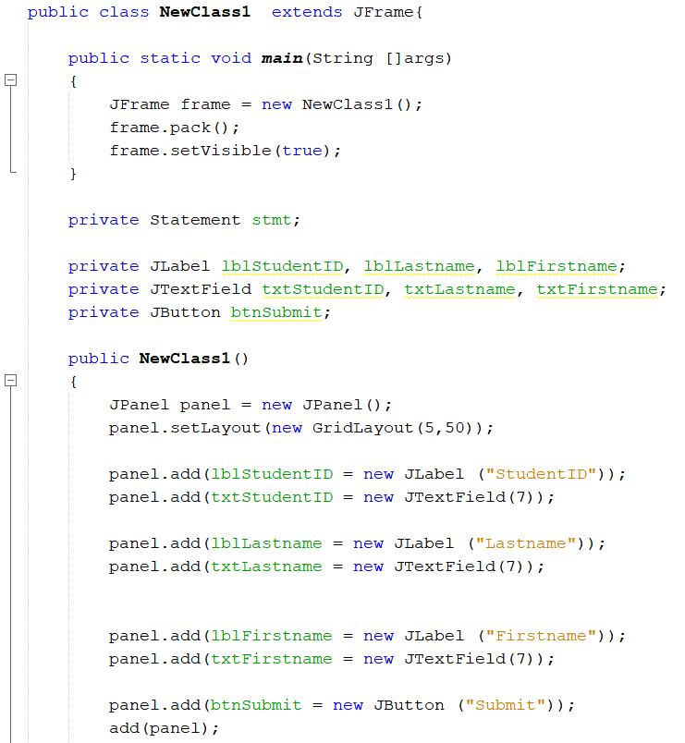

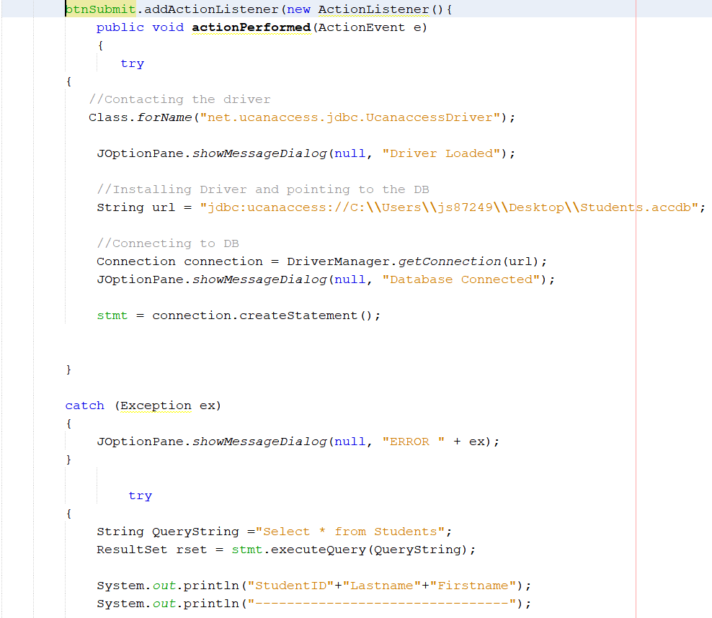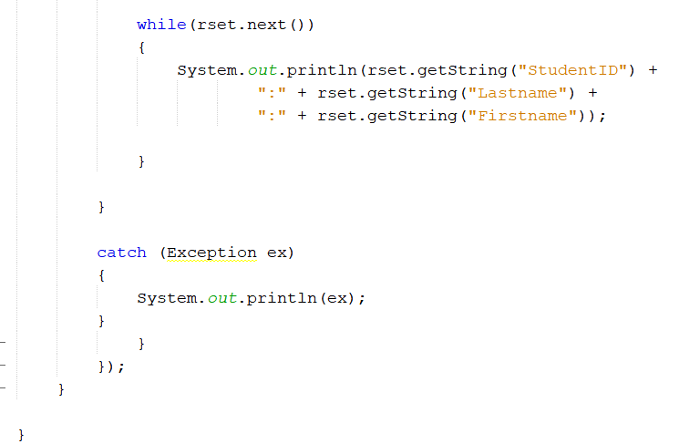

1. The last thing to do is to import the necessary .jar files, go to Canvas and Download the 5 .jar files, they are named as shown below:

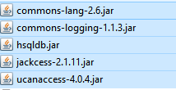

1. Import them into the Java Libraries

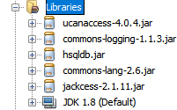

**Challenge Exercise #1**

Create an Insert, Update and Delete JButtons and perform the functions so the Java App will be able to Insert a new row, update and or delete rows

**#1 print screen the confirmation after the insert button is clicked with the INSERT code below here.**

**#2 print screen the confirmation after the update button is clicked with the UPDATE code below here.**

**#3 print screen the confirmation after the delete button is clicked with the DELETE code below here.**

**Project #2**

Import the Coffee text file from Canvas to the access database. Then complete the following queries

1. Write the sql script to retrieve all coffee brands where price is greater than $8.00

**#4 print screen the output with sql script below here.**

1. Write the sql script to retrieve all coffee brands for Kona, use the like statement.

**#5 print screen the output with sql script below here.**

1. Write the sql script to retrieve all prod nums that ends with the number 1, use the like statement.

**#6 print screen the output with sql script below here.**

**Challenge Exercise #2**

Based on the project #2 queries a-c, create a j table to display all of the three queries in a j table.

**#7 print screen only the output for each of the three queries below here.**

**Challenge Exercise #3**

The SQL syntax is based on the joining for the students and courses tables.



Save the JOIN as ERD then create a new query and create a table based on the inner ERD, you will see the table appear on the left hand-side

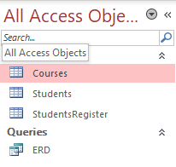

Right click on the StudentRegister and click on the Design View and modify as shown below

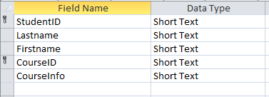

Save and the table should look somewhat as shown below



Display the new table (StudentRegister) using a J Table.

Add the following columns to the student’s table

* Address
* City
* State
* Zipcode

Enter data into the new columns and display the student’s data in the J Table.

**#8 print screen the output of the j table below here.**

**Submit this document to Module 10 class exercise.**